U18CO018

Shubham Shekhaliya

Assignment-4 (ST)

1-> Write a PHP program to validate email using a user-defined function.

<!DOCTYPE html>

<html>

    <head>

        <title>Validate Email</title>

    </head>

    <body>

        <form method="post" action="First.php">

            <label for="email">Email:</label>

            <input name="email" type="text">

            <button type="submit" value='Submit'> Submit</button>

        </form>

        <?php

            if($_SERVER["REQUEST_METHOD"] == "POST") {

                $ans = "";

                $str = $_POST["email"];

                if(!empty($_POST["email"]) and preg_match("^[_a-z0-9-]+(\.[_a-z0-9-]+)*@[a-z0-9-]+(\.[a-z0-9-]+)*(\.[a-z]{2,3})$^", $str) ) {

                    $ans =  "Your Email address is ".$str;

                } else {

                    $ans = "Email address is not valid";

                }

                echo $ans;

                echo "</br>";

            }

        ?>

    </body>

</html>

Output:-

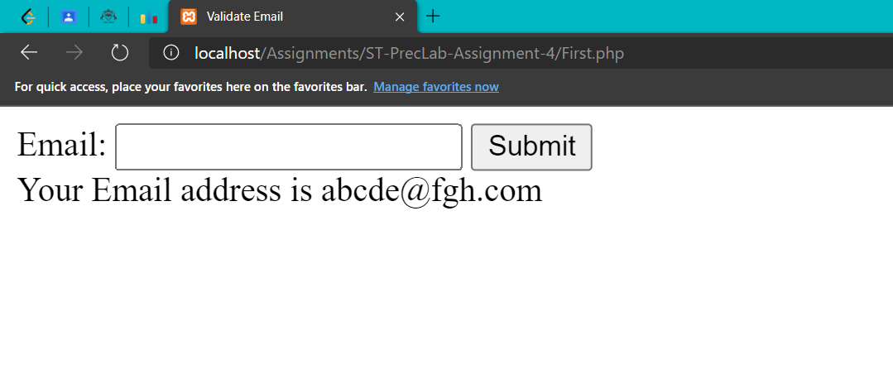

2-> Write a program to create a Chess Board in PHP.

<!DOCTYPE html>

<html>

    <head>

        <title>Chess</title>

    </head>

    <body>

        <table width="400px" cellspacing="0px" cellpadding="0px" border="1px">

            <?php

            for($row=1;$row<=8;$row++){

                echo "<tr>";

                for($column=1;$column<=8;$column++){

                    $total=$row+$column;

                    if($total%2==0){

                        echo "<td height=40px width=40px bgcolor=#FFFFFF></td>";

                    }

                    else{

                        echo "<td height=40px width=40px bgcolor=#000000></td>";

                    }

                }

                echo "</tr>";

            }

            ?>

        </table>

    </body>

</html>

Output:-

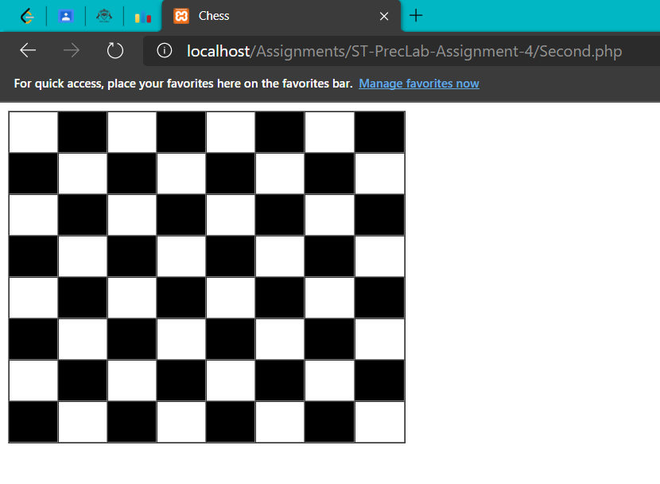

3-> Write a program to demonstrate a filter_var function in PHP.

<!DOCTYPE html>

<html>

    <head>

        <title>FilterVarFunction</title>

    </head>

    <body>

        <form method="post" action="Third.php">

            <label for="email">Email:</label>

            <input name="email" type="text">

            <button type="submit" value='Submit'> Submit</button>

        </form>

        <?php

            if($_SERVER["REQUEST_METHOD"] == "POST") {

                $str = $_POST["email"];

                $ans="";

                if(!empty($_POST["email"]) and filter_var($str, FILTER_VALIDATE_EMAIL) ) {

                    $ans =  "Email address is valid";

                } else {

                    $ans = "Email address is not valid";

                }

                echo $ans;

                echo "</br>";

            }

        ?>

    </body>

</html>

Output:-

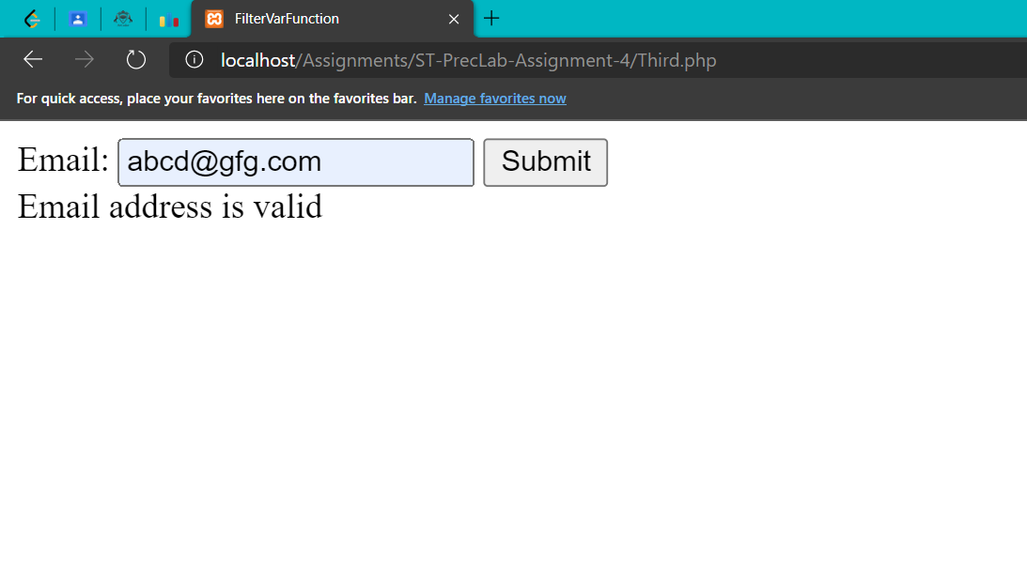

4-> Write a program to implement a basic search engine.

<!DOCTYPE html>

<html>

    <head>

        <title>Validate Email</title>

    </head>

    <body>

        <p>The following Pages are present</p>

        <p>Covid 19</p>

        <p>SVNIT</p>

        <p>DSA</p>

        <p>DAA</p>

        <p>AIML</p>

        <form method="post" action="Four.php">

            <label for="query">Enter Here:</label>

            <input name="query" type="text">

            <button type="submit" value='Submit'>Search</button>

        </form>

        <?php

            $query = "";

            if(!empty($_POST["query"])) {

                $query = $_POST["query"];

                if($query == 'Covid 19' or $query=='covid 19') {

                    echo "<h2>Covid 19</h2>";

                    echo "<p>Covid 19 is now a global pandemic.<br>

                          Millions of people affected by it are now eagerly waiting for the situation to recover.<br>

                          We can only hope the situation get better.</p>";

                } else if($query == 'SVNIT' or $query=='svnit') {

                    echo "<h2>SVNIT</h2>";

                    echo "<p>SVNIT is one of the most prestigeous institute in India.<br>

                         Thousands of students wish to get the admission and hope for their dream come true.<br>

                         The institute is performing excellent in every aspect since last many years.</p>";

                } else if($query == 'DSA' or $query == 'dsa' ) {

                    echo "<h2>Data Structure and Algorithm</h2>";

                    echo "<p>Data structure and algorithm is interesting subject</p>

                          <p>This subject contains the basic concept of the Data sturcture like stack, queue, tree, Graph </p>

                          <p>and Introduction to the algorithm like Serching, Sorting, greedy algorithm, Tree traversal and graph algorithm</p>";

                } else if ($query == 'DAA' or $query == 'daa') {

                    echo "<h2>Design and Algorithm Analysis</h2>";

                    echo "<p>This is subject contains Running time and space complexity of the Algorithm</br>

                          We get knowledge about the Greedy Algorithm ,Dynamic Programming and Divide and conqure<br>

                          And various algorithm analysis technique</p>";

                } else if ($query == 'aiml' or $query == 'AIML' ) {

                    echo "<h2>Artificial Intelligence and Machine Learning</h2>";

                    echo "<p>This subject is to the introduction to the Artifiacial Intelligence and Machine Learining</p>";

                } else {

                    echo "The search term DOES NOT EXIST";

                }

            }

            else {

                echo "Please Enter a valid string";

            }

        ?>

    </body>

</html>

Output:-

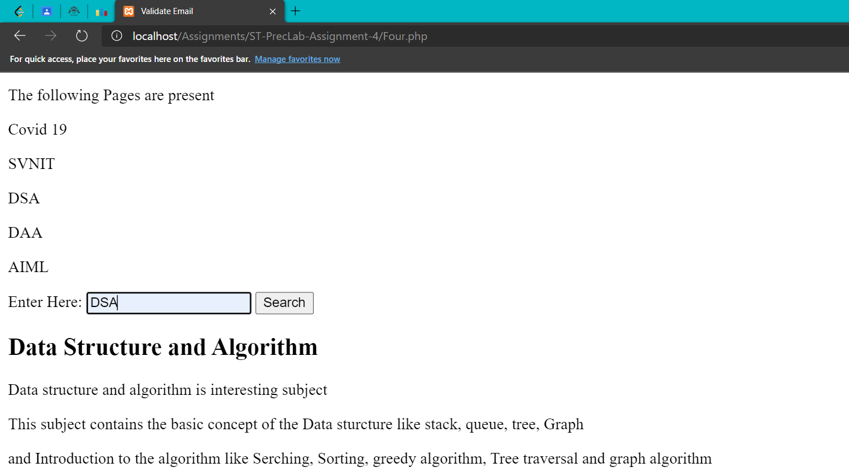

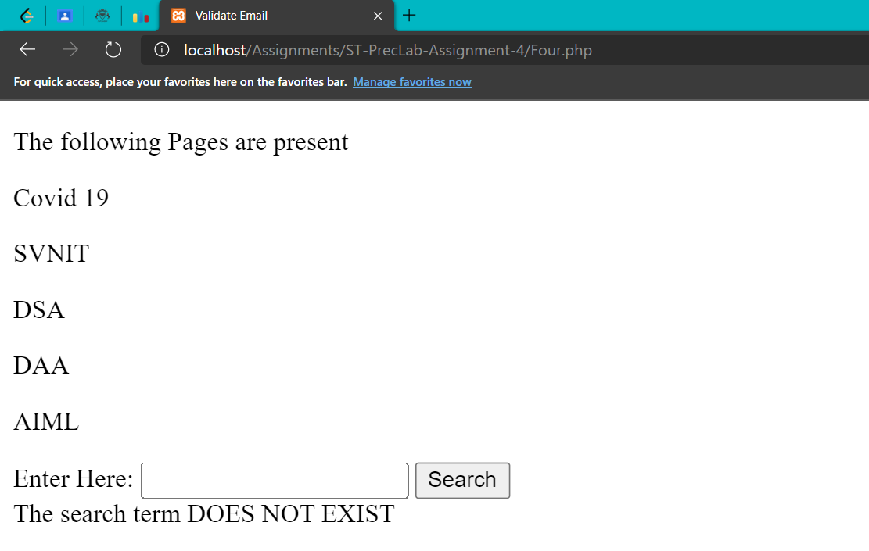

5-> Create a student Registration form using HTML Form elements and display all student information on another page using PHP. Validate all the fields.

Five.php

<!DOCTYPE html>

<html>

<head>

    <meta charset="utf-8" />

    <title>Registration Form</title>

    <meta name="viewport" content="width=device-width, initial-scale=1">

    <link rel="stylesheet"

href="https://maxcdn.bootstrapcdn.com/bootstrap/3.4.1/css/bootstrap.min.css">

    <style>

        .form {

            width: 33%;

            margin-top: 5%;

            margin-left: 33%;

            background: #52c8ec;

            border-radius: 5px;

            margin-bottom: 5%;

        }

        body {

          font-family: 'Nunito', sans-serif;

          font-size: 20px;

          background: #531834;

        }

        label {

          display: block;

          margin-bottom: 8px;

        }

        input[type="text"],input[type="password"],input[type="email"],

input[type="date"],input[type="datetime"],input[type="email"],

        input[type="number"],input[type="search"],input[type="tel"],

input[type="time"],input[type="url"],textarea,select {

          background: rgba(255,255,255,0.1);

          font-size: 18px;

          padding: 15px;

          width: 100%;

          background-color: #b145b1;

          color: #ffffff;

          margin-bottom: 30px;

        }

        .fieldset div {

          padding-left : 30px;

          padding-right: 30px;

          padding-bottom: 15px;

        }

        .btn {

            background-color: #ff7402;

            color: black;

            margin-left: 27%;

            border: 2px solid #e7e7e7;

        }

    </style>

</head>

<body>

    <form class="form" name="form" action="Five-Help.php" method="POST"

enctype="multipart/form-data">

        <div class="fieldset">

            <div style="padding-top: 30px; margin-bottom: 20px;">

              <label for="name">Name:</label>

              <input type="text" name="name" style="margin-bottom: 0px;">

              <small style="text-decoration: bold; font-size: 15px;">

Enter Letters Only </small>

            </div>

            <div>

              <label for="email">Email:</label>

              <input type="email" name="email">

            </div>

            <div>

              <label for="dob">DOB:</label>

              <input type="date" name="dob">

            </div>

            <div >

              <label for="mobile">MobileNumber:</label>

              <input type="tel" name="mobile" style="margin-bottom: 0px;">

              <small style="text-decoration: bold; font-size: 15px;">

Sample Format : 9876543210 </small>

            </div>

            <div >

              <label for="gender">Gender:</label>

              <input type="radio" name="gender" value="male">

<span style="display:inline-block;"> Male </span>

              <input type="radio" name="gender" value="female">

<span style="display:inline-block;"> Female </span> <br>

            </div>

            <div>

              <label for="post">Post:</label>

              <input type="radio" name="post" value="webDeveloper">

<span style="display:inline-block;"> Web Developer </span>

              <input type="radio" name="post" value="programmer">

<span style="display:inline-block;"> Programmer </span>

              <input type="radio" name="post" value="manager">

<span style="display:inline-block;"> Manager </span> <br>

            </div>

            <div>

              <label for="idCard">Upload Id Card:</label>

              <input type="file" name="idCard">

            </div>

            <div style="margin-top: 15px;">

              <input type="submit" style="height: 50px; width: 200px;

font-size: 20px; color: #ffffff;" name="submit" class="btn">

            </div>

        </div>

    </form>

</body>

</html>

Five-Help.php

<?php

    $name = "";

    if(!empty($_POST["name"])) {

        $name = $_POST["name"];

        $name = trim($name);

        if(preg_match("/^[A-Za-z ]+$/",$name)){

            $name = "Welcome " . $name ." !! <br>";

        } else {

            $name = "You entered Invalid Name <br>";

        }

    } else {

        $name = "Enter the Name <br>";

    }

    $email = "";

    if(!empty($_POST["email"])) {

        $email = $_POST["email"];

        $email = trim($email);

        if(filter_var($email, FILTER_VALIDATE_EMAIL)) {

            $email = "Your Email address :  " . $email . "<br>";

        } else {

            $email = "You entered Invalid Email address <br>";

        }

    } else {

        $email = "Enter the email <br>";

    }

    $date = "";

    if(!empty($_POST["dob"])) {

        $date = $_POST["dob"];

        $date = date("Y-m-d",strtotime($date));

        list($y, $m, $d) = explode("-", $date);

        if(checkdate($m,$d,$y)) {

            $date = "Date of the birth " . $date . "<br>";

        } else {

            $date = "you entered invalid date of the Birth <br>";

        }

    } else {

        $date = "Enter the date of the Birth <br>";

    }

    $mobilenumber = "";

    if(!empty($_POST["mobile"])) {

        $mobilenumber = $_POST["mobile"];

        if(is_numeric($mobilenumber) and strlen($mobilenumber) == 10) {

            $mobilenumber = "Your mobile number is " . $mobilenumber . "<br>";

        } else {

            $mobilenumber = "You entered invalid mobile number <br>";

        }

    } else {

        $mobilenumber = "Enter the mobile number <br>";

    }

    $gender ="";

    if(!empty($_POST["gender"])) {

        $gender = "You entered Gender as " . trim($_POST["gender"]) . "<br>";

    } else {

        $gender = "Select the Gender <br>";

    }

    $job ="";

    if(!empty($_POST["post"])) {

        $job = "You are applying for the post of " . trim($_POST["post"]) . "<br>";

    } else {

        $job = "Select the Post <br>";

    }

    if(isset($_POST['submit'])) {

        $idCard = "";

        $target_dir = "uploads/";

        $target_file = $target_dir . basename($_FILES["idCard"]["name"]);

        $fileType = strtolower(pathinfo($target_file,PATHINFO_EXTENSION));

        if(isset($target_file)){

            $idCard = "Upload Id card !! <br>";

        } else if (file_exists($target_file)) {

            $idCard = "Sorry, file already exists. <br>";

        } elseif ($_FILES["idCard"]["size"] > 1000000) {

            $idCard  = "Enter less than 1000KB File<br>";

        } elseif ($fileType != "pdf") {

            $idCard  =  "Sorry, only PDF files are allowed. <br>";

        } elseif (@move_uploaded_file($_FILES["idCard"]["tmp_name"], $target_file)) {

            $idCard = "File uploaded. <br>";

        } else {

            $idCard = "There is some error while submitting file <br>";

        }

    }

    echo $name . $email . $mobilenumber . $date . $gender . $job . $idCard;

?>

Output :-

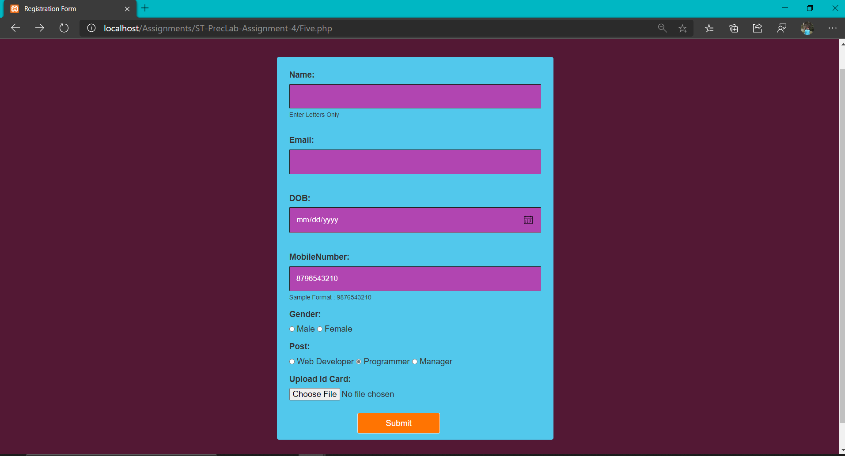

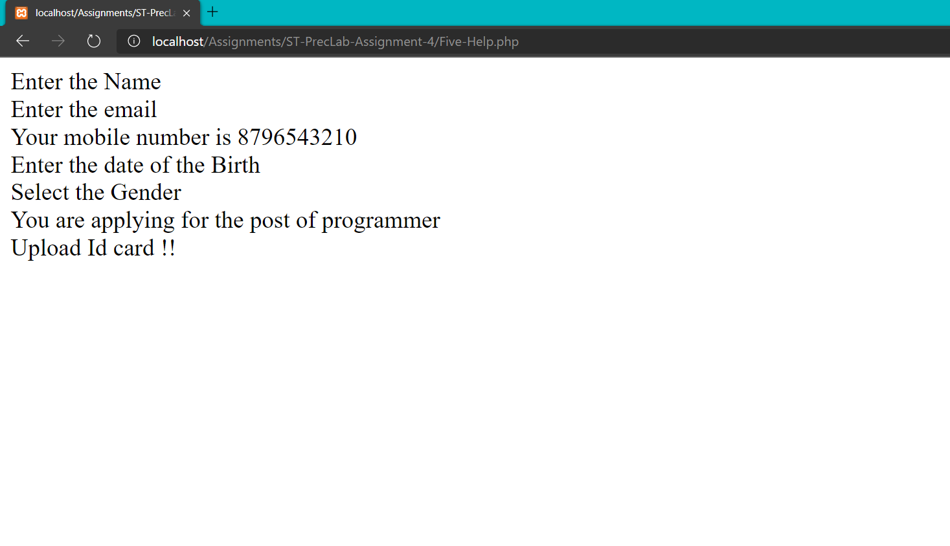

6-> Write a PHP script to make a web application take a name as input and on submit it shows a hello <name> page where <name> is taken from the request. And provide a

logout button on clicking this button it should show a logout page with a thank you <name> message.

Six.php

<!DOCTYPE html>

<html>

    <body>

        <form method="POST" action = "SixthSession.php">

            <label for="name">Name: </label>

            <input name = "name" type="text">

            <input type="submit" value="Log In">

        </form>

    </body>

</html>

SixthSession.php

<!DOCTYPE html>

<html>

    <?php

        session_start();

        $_SESSION["name"] = $_POST["name"];

        if(isset($_SESSION["name"]) && !empty($_SESSION["name"])) {

            echo "Welcome, " . $_SESSION["name"];

            echo "</br>";

            echo "Logged in";

            echo "</br>";

            echo "<a href='sixHelp.php'>To logout click here!!!</a>";

            echo "</br>";

        } else {

            echo "Something went wrong";

            echo "</br>";

            echo "<a href = 'sixth.php'>Go back to the home page</a>";

            echo "</br>";

        }

    ?>

</html>

SixHelp.php

<!DOCTYPE html>

<html>

    <?php

        session_start();

        session_destroy();

        echo 'Thank you';

        echo "</br>";

        echo "Logged out";

        echo "</br>";

        echo "<a href = 'six.php'>Go back to the home page</a>";

    ?>

</html>

